Cleobury Mortimer Primary School
Dear Colleague,

Thank you for considering our Headteacher vacancy at Cleobury Mortimer Primary School. Cleobury Mortimer Primary is an is an excellent school, dedicated to serving its community. It is seeking an outstanding headteacher to lead it to the next phase of its development and success.
The school is part of a unique, mixed multi academy trust: The Shropshire Gateway Education Trust. The Trust has primary, secondary, church and non-denominational schools working together to improve the educational experience for our children in South Shropshire.
We passionately believe in the power of partnership working as a catalyst for ensuring more children receive an exceptional education. At the same time, we recognise the importance of autonomy; every academy has its own context and challenges. This is why we encourage our member academies to lead and manage in a way that preserves their individual identity and responds to the specific needs of their children and community.
The combination of autonomy and collaboration across key areas of leadership and management, curriculum, CPD and leadership but underpinned by a shared vision, values and best practice is what makes the Shropshire Gateway Educational Trust unique.
As Headteacher of Cleobury Mortimer Primary School, you will become an important part of this strong family. We hope the following information helps you understand our school and we greatly look forward to receiving your application,
Yours Sincerely,
Katie Jones

Executive Headteacher
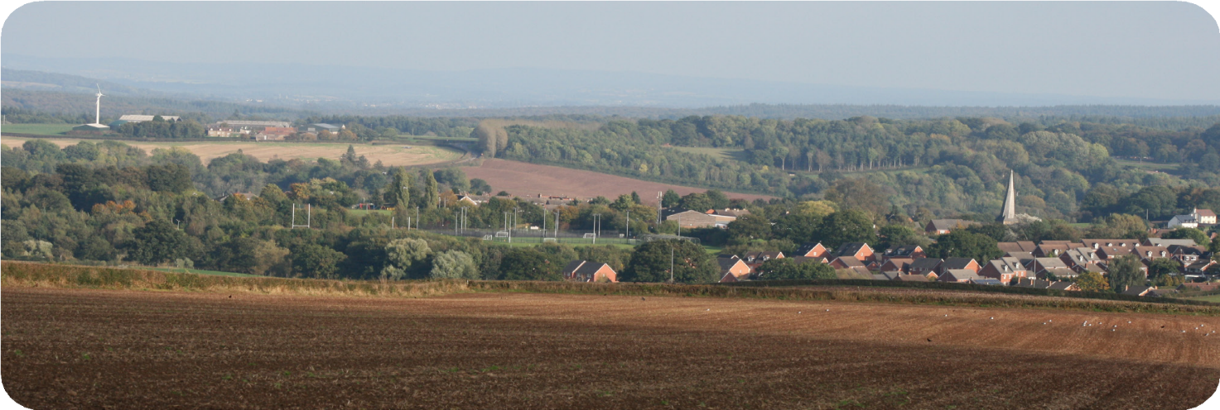
The Shropshire Gateway Educational Trust
Cleobury Mortimer, Shropshire DY14 8PE

Headteacher Application Recruitment Pack

Cleobury Mortimer Primary School

A very warm welcome to Cleobury Mortimer Primary School.
We are extremely proud of our school, the achievements of our pupils, the expertise and dedication of our hard- working staff and of the active part we play in our local community.

Our school is located in the small South Shropshire town of Cleobury Mortimer which is surrounded by rolling hills and beautiful countryside. We currently have 274 children organised into ten classes ranging from 2 to 11 years old. We are proud of the welcoming and friendly atmosphere of the school, where children work co-operatively to achieve the very best they possibly can in all areas of the curriculum.

Establishing and maintaining good relationships between staff and children is very important to us, and the supportive, nurturing ethos of the school bears witness to our success in this area. We always strive to achieve the highest possible standards, but also work hard to provide a broad and balanced curriculum which is enjoyable and fun.

Our mission statement is
Cleobury Mortimer Primary School is a safe, healthy, happy and secure learning community. We aim to create a stimulating and challenging high quality learning environment which promotes respect and tolerance so that all members of school community can achieve their full potential. We celebrate the uniqueness of all members of our community

The school is a well maintained property, with many recent improvement projects completed, and we have recently completed the construction of a specialist SEN Hub catering for children who have additional learning needs.

OFSTED 2017 - This is a Good School.

Cleobury Mortimer Primary School

SEND.

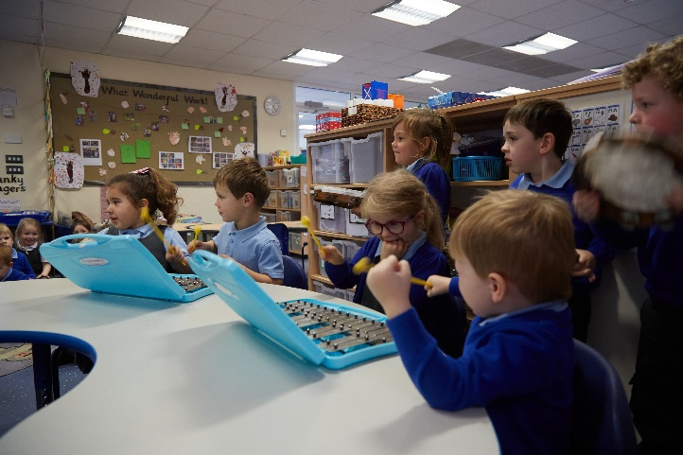
At Cleobury Mortimer Primary School we are committed to ensuring that all children achieve their full potential, regardless of any additional learning need they may have.

There is a shared expectation that all pupils, regardless of their specific needs, should be offered inclusive teaching which will enable them to make the best possible progress in school and feel that they are a valued member of the wider community.

Wherever possible, we seek to provide ways to support all pupils to engage with the wide range of learning activities and experiences on offer through-out the school, enabling inclusion and promoting confidence and independence for all.

We do this by working closely with parents, pupils and professionals to encourage the sharing of views and participation in decision making. Included in the process is our team of talented, dedicated and skilled staff working to provide the best possible inclusive outcomes.

We have developed excellent links with multi-agencies to further develop our own skills and enable us to draw on expertise in a variety of areas. During 2022 we added a specialist SEND Hub to further enhance the support available to our community and beyond.

Cleobury Mortimer Primary School

About our community.
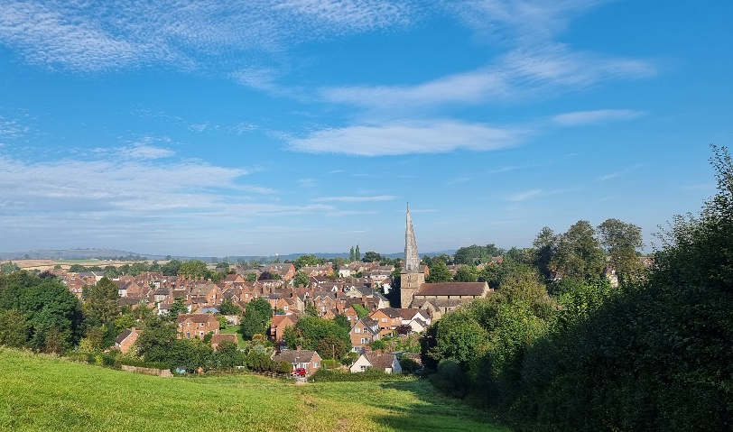
Located in one of the most beautiful areas of the country, Cleobury Mortimer is a small, yet vibrant and growing town situated on the edge of Shropshire, just 30 miles to the west of Birmingham. Cleobury is bordered by Worcestershire to the south, Herefordshire to the west and is an easy commutable distance from the towns or cities of Shropshire, Herefordshire, Worcestershire, Wolverhampton and, of course, Birmingham. Other nearby towns include Bewdley, Ludlow and Bridgnorth.

To the East of the town are the Clee Hills, which has the highest summit south of the Pennines, therefore making it an ideal place for walking and country living. For leisure activities further afield, Aberdovey, on the Welsh coast, is two hours by road and even the Snowdonia National Park can be reached in under three.

The town itself has a number of shops producing local and fresh produce, most of which are independently owned and run by local people to the town. It also has amenities that include a doctors, dentist, seven public houses, cafes, beauticians, a chiropractor, chiropodist, hairdressers and several restaurants offering a range of cuisines.

Cleobury Mortimer’s position in the beautiful county of South Shropshire makes it a very desirable place to live with the tranquil and friendly environment it offers alongside the benefits of a close distance to greater hustle and bustle.

The average price for property in the Cleobury Mortimer area was £300K in December 2021 and with 4 bed detached houses being offered around £400K

Cleobury Mortimer Primary School

Thank you for the interest you have shown in working for our Academy. Please ensure you read the form carefully, completing and returning all sections and any requested additional information. Your completed application and supplementary information should be submitted to Cheryl.Grove@cmpschool.co.uk by the time/date specified as the closing date on the job advertisement.
GUIDANCE/INFORMATION TO APPLICANTS:

If you have any questions about the completion of the application form, or if you require this form in an alternative format, please contact the Academy for assistance.

The Trust is committed to safeguarding and promoting the welfare of children and young people and expects all staff and volunteers to share this commitment.

Decision to shortlist:
Your application form is an important part of the recruitment process. The decision whether or not to shortlist you for interview will be based on the information you provide on your application form; we do not take into account any previous applications or prior knowledge of you. Before you start to complete the application please read the Job Description and Person Specification carefully. These detail the knowledge, experience, skills and abilities needed. You should address how you meet these in your letter of application.

Recruitment monitoring form:
We positively welcome applications regardless of age, gender, cultural and ethnic origin, religion, disability, gender and sexuality. To help monitor the effectiveness of our recruitment practices, to assess whether we are meeting the Public Sector Equality Duty and whether we are complying with relevant legislation, please complete the enclosed equality form and return it with your application. It is used for statistical purposes only.

Application feedback:
If you do not hear from us within two weeks of the closing date, please assume that you have not been shortlisted to attend an interview. If you would like to request feedback or have any queries / complaints about our recruitment procedures, please contact us via Cheryl.Grove@cmpschool.co.uk .
DATA PROTECTION NOTICE
Throughout our application form we ask for some personal data about you. We will only use this data in line with data protection legislation and process your data for one or more of the following reasons permitted in law: · You have given us your consent. · We must process it to comply with our legal obligations.

Cleobury Mortimer Primary School.
Cleobury Mortimer Primary School is a highly inclusive Academy with a vision to provide a safe, healthy, happy and secure learning community with a stimulating and challenging learning environment.

The Board of Governors are seeking to appoint an outstanding and inspirational Headteacher.

We have a talented and highly committed staff, supportive governors and amazing pupils.

Our buildings have excellent facilities and the Trust consistently ensures excellent financial management.

The school has worked hard to secure consistently excellent outcomes for our pupils and has a strong commitment and practice in teacher and leadership development.

We are excited to appoint a new Headteacher who will lead us on the next stage of our journey.
The successful candidate will be someone who is:
- A highly experienced senior leader, with the vision to identify the next steps on our improvement journey and the energy, drive and skills to lead and realise this.
- An outstanding role model who is relentlessly committed to the community and improving the lives of the pupils in their care.
- Absolutely committed to ensuring that all children achieve their full potential, regardless of any additional learning need they may have.
- An inspirational leader able to engage and motivate all stakeholders.
- Able to secure the highest educational standards whilst ensuring a culture and practice of care, wellbeing and support for our staff and pupils.
We will offer the successful candidate an amazing school to lead, significant support and opportunities for professional development.

The governors expect our pupils and staff to be challenged, motivated, respected, celebrated and most of all, inspired under the leadership of our new Headteacher. If this challenge excites you, we would love to talk to you about the prospect of becoming our new Headteacher.

Prospective candidates are warmly encouraged to visit the school and opportunities to do this will be available in weeks beginning 4th and 25th April 2022. To enquire about visits and make an appointment, in the first instance please email: Mrs Cheryl Grove, on Cheryl.Grove@cmpschool.co.uk

Start date : Preferably September 2022 (or later depending on candidate)

Salary : Group 2 – L14 to L20

Closing date : Tuesday 3rd May 12 noon

Interviews : 16th and 17th May 2022

On our website and within the application pack, you will find a range of documents that tell you more about the role and who we are looking for.

www.cmpschool.co.uk

www.sget.org.uk
To apply for this position please download the application form from our website and send completed applications and supporting documentation to Cheryl.Grove@cmpschool.co.uk by the closing date.

Cleobury Mortimer Primary School and The Shropshire Gateway Educational Trust are committed to safeguarding and promoting the welfare of children, young people and vulnerable adults and expect all staff and volunteers to share this commitment.

The successful candidate will have to meet the person specification, they will also be required to apply for an enhanced DBS disclosure and all other pre-employment checks outlined in Keeping Children Safe in Education.

We particularly welcome applicants from under-represented groups including those based on ethnicity, gender, transgender, age, disability, sexual orientation or religion.

We follow a strict pre-employment process in line with Safer Recruitment / Keeping Children Safe in Education. All appointments are subject to satisfactory pre-employment checks.

The Shropshire Gateway Educational Trust
Cleobury Mortimer Primary School.

JOB DETAILS

Salary: Headteacher school range Group 2 – L14 to L20

Contract type: Permanent

Reporting to: The Cleobury Mortimer Primary School Governing Board.
The Shropshire Gateway Educational Trust Executive Headteacher.
The Shropshire Gateway Educational Trust Board of Directors.
Member of the Shropshire Gateway Educational Trust Headteacher Board.

Main purpose
The headteacher will:
- Establish and sustain the school’s ethos and strategic direction together with the governing board and through consultation and engagement with the school and wider community
- Establish and oversee systems, processes and policies so the school can operate effectively
- Identify problems and barriers to school effectiveness, and develop strategies for school improvement that are realistic, timely and suited to the school’s context
- Make sure these school improvement strategies are effectively implemented
- Monitor progress towards achieving the school’s aims and objectives
- Allocate financial resources appropriately, efficiently and effectively
- Add value to the Trust by actively engaging in Trust strategy, activities, policies and procedures

Qualities

The headteacher will:
- Uphold public trust in school leadership and maintain high standards of ethics, behaviour and professional conduct
- Build positive and respectful relationships across the school community
- Serve in the best interests of the school’s pupils
- Have an understanding of working with children with different abilities

Duties and Responsibilities
School culture and behaviour

The headteacher will:
- Create a culture where pupils experience a positive and enriching school life
- Uphold educational standards in order to prepare pupils from all backgrounds for their next phase of education and life
- Ensure a culture of staff professionalism
- Encourage high standards of behaviour from pupils, built on rules and routines that are understood by staff and pupils and clearly demonstrated by all adults in school
- Use consistent and fair approaches to managing behaviour, in line with the school’s behaviour policy
- Work with Trust member schools to create a collaborative approach to teaching and learning across the Trust
Teaching, curriculum and assessment
The headteacher will:
- Establish and sustain high-quality teaching across all subjects and phases, based on evidence
- Ensure teaching is underpinned by subject expertise
- Effectively use formative assessment to inform strategy and decisions
- Ensure the teaching of a broad, structured and coherent curriculum
- Establish curriculum leadership, including subject leaders with relevant expertise and access to professional networks and communities
- Use valid, reliable and proportionate approaches to assessing pupils’ knowledge and understanding of the curriculum
Additional and special educational needs (SEN) and disabilities
The headteacher will:
- Promote a culture and practices that enables all pupils to access the curriculum
- Have ambitious expectations for all pupils with SEN and disabilities
- Ensure the school works effectively with parents, carers and professionals to identify additional needs and provide support and adaptation where appropriate
- Make sure the school fulfils statutory duties regarding the SEND Code of Practice
Managing the school
The headteacher will:
- Ensure staff and pupils’ safety and welfare through effective approaches to safeguarding, as part of duty of care
- Manage staff well with due attention to workload
- Ensure rigorous approaches to identifying, managing and mitigating risk
- Demonstrate effective use of public funds in line with the Academy Trust handbook

Professional development
The headteacher will:
- Ensure staff have access to appropriate, high standard professional development opportunities
- Keep up to date with developments in education
- Seek training and continuing professional development to meet needs
Governance, accountability and working in partnership
The headteacher will:
- Understand and welcome the role of effective governance, including accepting responsibility
- Report as required to the Governing Board and the Trust Executive Headteacher
- Ensure that staff understand their professional responsibilities and are held to account
- Ensure the school effectively and efficiently operates within the required regulatory frameworks and meets all statutory duties
- Work successfully with other schools and organisations
- Maintain working relationships with fellow professionals and colleagues to improve educational outcomes for all pupils

Please note that this is illustrative of the general nature and level of responsibility of the role. It is not a comprehensive list of all tasks that the headteacher will carry out. The postholder may be required to do other duties appropriate to the level of the role.

Person specification

CRITERIA | QUALITIES (E - Essential, D - Desirable)
Qualifications and training | - Qualified teacher status (E)  - Degree (E)  - National professional qualification for headship (NPQH) (D)  - Evidence of further continual development (E)
Experience | - Successful leadership and management experience, with a track record of raising standards, managing change and leading innovation(E)  - Involvement in school self-evaluation and development planning (E)  - Working with children with SEND (E)  - Leading and developing staff through effective professional development and performance management (E)  - Track record of raising standards, managing change, leading innovations and successfully meeting challenges (E)  - Successful collaboration with parents, Governors, partner schools and other organisations within the wider community (D)
Skills and knowledge | - Broad range of data analysis skills, including the ability to use data to set targets/ identify weaknesses and interpret financial data (E)  - Understanding of high-quality teaching based on evidence, and the ability to model this for others and support others to improve (E)  - Understanding of school finances and financial management (E)  - Effective communication and interpersonal skills (E)  - Ability to communicate a vision and inspire others (E)  - Ability to build effective working relationships (E)  - Robust ability to use a range of IT systems for school management (E)
Personal qualities | - Commitment to uphold the 7 principles of public life (the Nolan principles) at all times (E)  - A passion for getting the best outcomes for all pupils and promoting the ethos and values of the school (E)  - Ability to work under pressure and prioritise effectively(E)  - Commitment to maintaining confidentiality at all times(E)  - Commitment to safeguarding, inclusiveness and equality, ensuring that personal beliefs are not expressed in ways that exploit the position (E)  - Excellent communication and presentation skills (E)

Notes:
This job description may be amended at any time in consultation with the postholder.

Last review date: 28th March 2022
Next review date: February 2023

Signed: Chair of Governing Board Date: 28th March 2022

“Thank you for your interest. We look forward to receiving your application”

